**Poynting’s Python Society Spr10: Project Ideas**

**Introduction**

The best way to improve your programming skills is to take up and work on your own projects – therefore, this worksheet provides a handful of ideas that you can use and work on in your spare time and the summer.

Extra-curricular projects like these are great to have on your CV and talk about during interviews with employers, so I’d highly recommend spending a little time this summer (once exams are over), working through your own project!

**Mandlbrot Set**

The Mandlbrot Set is the set of complex numbers, c for which the iterative function $z_{n+1}=z_{n}^{2}+c$, ($z_{0}=c$) doesn’t diverge to infinity.



Figure 1: The Mandlbrot set (black) within continuously colored environment ([source](https://en.wikipedia.org/wiki/Mandelbrot_set#/media/File:Mandel_zoom_00_mandelbrot_set.jpg))

The boundary of the Mandlbrot set is a famous fractal curve shown in Fig. 1.

First target for this project is to produce a plot of all points within domain $D=\{x+iy\left|-1.5<x<0.5,-1.2<y<1.2\right\}$.

Try restricting this domain into the *seahorse valley* centered around $z=-0.7$, you should find patterns like that shown in Fig. 2

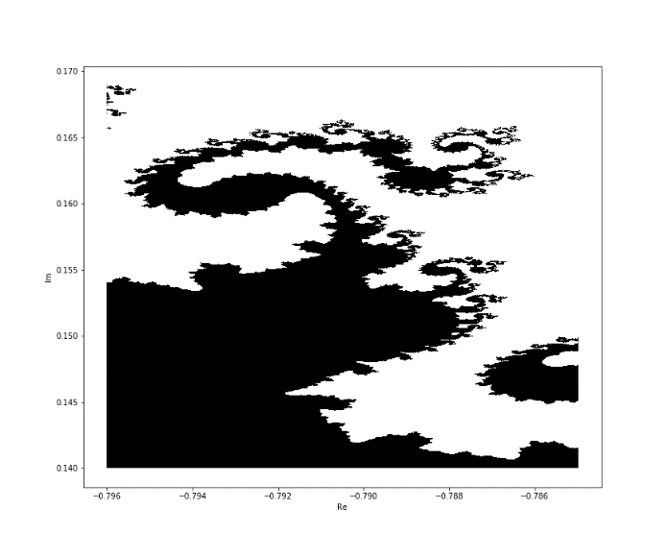

Figure 2: Zooming into seahorse valley

**Wordle**

Create a programme that searches a dictionary of 5 letter words to help you solve the wordle of the day.



Figure 3: Wordle 196 ([source](https://en.wikipedia.org/wiki/Wordle))

Each guess provides you with new information about the target word, and so you can slowly decrease the size of the dictionary you have to look through – grey letters allow you to eliminate all words containing that letter, yellow allow you to consider only letters with that letter, green allow you to consider only words with that letter in the specified place.

You could create a GUI that runs a concurrent game of wordle that also displays the list of possible words – this list should then be refined as you take more guesses.

This is quite a big project, so don’t worry if it takes you a while :)

**Ideal Gas Simulation**

Use many instances of a ‘molecule’ class to create a simulation of an ideal gas. There’s a separate worksheet for this one, found [here](https://we.tl/t-ZEpFjfUAb3).

You can verify the Maxwell velocity distribution curves by sampling the speeds of the particles in the box.

[**projecteuler.net**](https://projecteuler.net/archives)

Project Euler is a site with an archive of mathsy problems that could never be solved by hand – but which a computer can do quite easily.

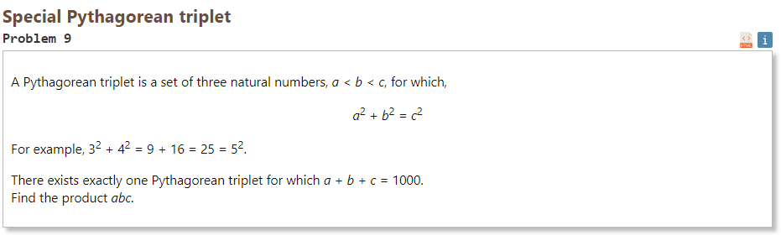

Figure 4: Screenshot of problem 9 from the Project Euler archive

You can submit your answers and keep track of your progress. These problems will help you get really really good at the basics of python and working with different data-types, which becomes absolutely necessary as you progress.